SIMPLE CHATBOT USING PYTHON

PROJECT REPORT



Submitted By : Swarnima Sah
25BAI10597

- This report is submitted as part of the Flipped Classroom Project requirements
- under the School of Computing Science and Engineering
VIT Bhopal.
1. Introduction
In today’s digital world, communication between humans and machines has become very important. Chatbots are one of the most common applications used for this purpose. A chatbot is a software program that can interact with users in a conversational way, either through text or voice.
This project focuses on developing a simple chatbot using Python programming language. The chatbot is designed to respond to user queries based on predefined keywords. Although it is not a fully intelligent system, it demonstrates the basic concept of how chatbots work.
The main goal of this project is to understand the working of conversational systems and implement a basic chatbot using simple programming logic.

2. Problem Statement
In many situations, users require quick responses to their queries without waiting for human assistance. For example, in colleges, students often have common questions related to courses, schedules, or general information.
However, it is not always possible to have a person available to answer these queries at all times. Therefore, there is a need for an automated system that can respond instantly.
This project aims to solve this problem by developing a simple chatbot that can handle basic user queries and provide immediate responses.

3. Functional Requirements
The functional requirements define what the system should do. The chatbot system includes the following functionalities:
- The system should accept user input from the keyboard
- The system should process the input text
- The system should identify keywords in the input
- The system should provide an appropriate response based on the input
- The system should display the response to the user
- The system should allow continuous conversation
- The system should exit when the user types "bye" or "exit"

4. Non-Functional Requirements
The non-functional requirements define how the system performs. These include:
- The system should be simple and easy to use
- The system should respond quickly
- The system should run on basic computers without high requirements
- The code should be readable and well-structured
- The system should be reliable for basic queries
- The system should not require internet connection

5. System Architecture
The chatbot follows a simple architecture:
User Input → Processing → Keyword Matching → Response Generation → Output Display
Explanation:
- The user enters a message
- The system processes the message
- Keywords are matched with predefined responses
- A suitable response is selected
- The response is displayed to the user
This architecture is simple and effective for beginner-level chatbot system.
6. Design Decisions and Rationale
Several design decisions were made while developing this project:
- A rule-based approach was chosen because it is simple and easy to implement
- Python was selected as the programming language due to its readability and simplicity
- A dictionary structure was used to store responses for better organization
- Functions were used to make the code modular and reusable
- Random response selection was implemented to make the chatbot feel more natural
These decisions helped in keeping the project simple while maintaining good structure and clarity.

7. Implementation Details
The chatbot is implemented using Python. The project consists of two main files:
- chatbot.py
  - This is the main program file
  - It handles user interaction
  - It processes input and prints responses
- utils.py
  - This file contains helper functions
  - It provides functions for time, date, and random responses
Working Process:
- The program starts and displays a welcome message
- The user enters input
- The input is converted to lowercase
- The program checks for keywords like "hi", "time", "date"
- Based on the keyword, a response is selected
- If no keyword matches, a default response is given
- The loop continues until the user exits

Screenshots / Results
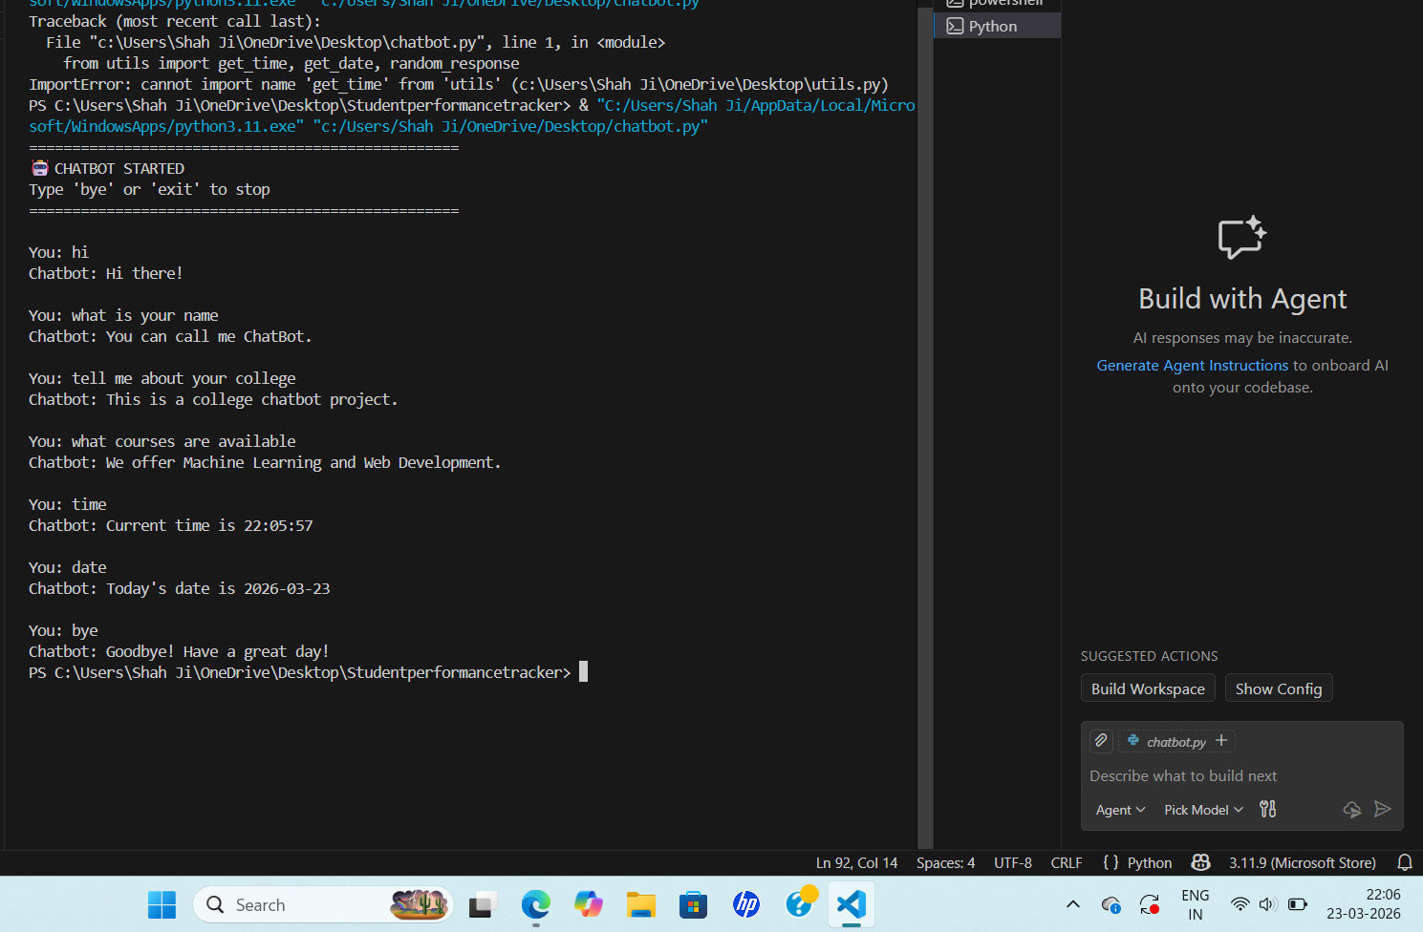
9. Challenges Faced
During the development of this project, several challenges were encountered:
- Handling different variations of user input
- Ensuring correct keyword matching
- Making responses feel natural and not repetitive
- Managing the flow of conversation
- Keeping the code simple yet functional
These challenges were addressed by improving logic and organizing the code properly.

10. Future Enhancements
This project can be improved in many ways:
- Integration of Natural Language Processing (NLP)
- Adding voice input and output features
- Creating a graphical user interface (GUI)
- Connecting to a database for storing conversations
- Using machine learning models for better responses
These improvements can make the chatbot more intelligent and user-friendly.

11. References
- Python Official Documentation: https://docs.python.org/
- Basic Python Tutorials
- Online learning resources for chatbot development

12. Conclusion
This project demonstrates how a simple chatbot can be developed using basic programming concepts. It shows that even without advanced AI techniques, it is possible to create a system that can interact with users.
The chatbot successfully performs basic conversation tasks and provides quick responses. This project serves as a good starting point for understanding chatbot development and artificial intelligence concepts.

